21.47: a) At the origin, 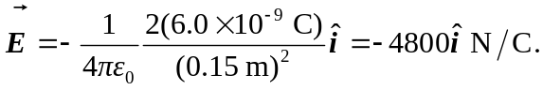
b) At 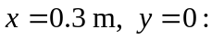
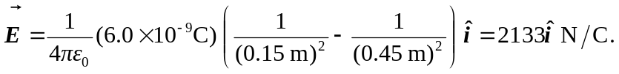
c) At 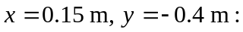
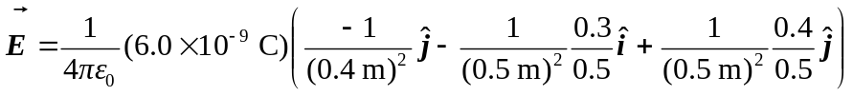
and 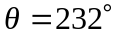 clockwise from 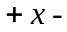axis.
d) 